**Financial Institutions and Markets**

**Assignment – 1**

Ashish Gokarnkar (18IM30027)

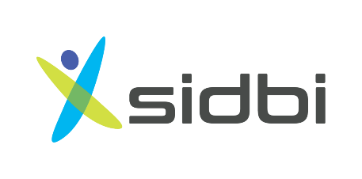

Small Industries Development Bank of India

# Introduction

Small Industries Development Bank of India (SIDBI) is a regulatory body established by the Government under a special Parliamentary Act on April 2, 1990. Initially, it was created as a subsidiary of the Industrial Development Bank of India (IDBI). SIDBI is the Primary Financial Institution for promoting, developing, coordinating, and financing MSME (Micro, Small and Medium Enterprise) sector. Key objectives of SIDBI are:

1. Aid financial institutions lending to small-scale industries in the MSME sector
2. Promote small-scale industries of India on a global scale
3. Promote and offer Venture Capital funding for Indian startups
4. Creating employment and tech advancement in SMEs
5. Ensure financial health of cooperative banks and commercial banks' lending to small-scale industries

SIDBI has shown these critical points for differentiating its loans from traditional financing:

* Tailor-Made
* Specialized Size
* Attractive Rates
* Venture/ Equity Funds
* Assistance
* Collateral Fee
* Transparency
* Risk & Growth Capital
* Government Subsidies

Product Horizontals & Verticals

SIDBI has 6 product divisions: direct financing, bills financing, refinancing, international financing, micro-financing, and fixed deposits. Normal economic products of SIDBI are:

1. Assistance to SFB & NBFCs
2. Refinance Scheme
3. Aspire Fund
4. Funds of Funds for startups
5. SIDBI Trader Finance Scheme (STFS)
6. SIDBI Make in India Soft Loan Fund for MSME (SMILE)
7. Small Equipment Finance (SEF)
8. Loan for Purchase of Equipment for Enterprise’s Development (SPEED)
9. Top Up Loan for Immediate Purposes (TULIP)
10. Working Capital (Cash Credit)
11. Retail Loan Scheme for financial traders (RLS)
12. Loans under partnership with OEM

The main objective of SIDBI is to help the small-scale industries, which are the base of all development, and create opportunities for their upliftment and funding. It finances these industries directly on a selective basis based on the applications it receives on its portal for various schemes. To support the MSME sector, it has created multiple initiatives, namely:

* Sampark – connect with MSMEs and entrepreneurs
* Samwad – strengthen relationship b/w stakeholders of MSME sector
* Suraksha – creating an enabling environment in India for growth of MSE
* Sampreshan – constructive engagement with policymakers and MSE entrepreneurs
* State MSME outreach program
* Udyam Sangyaan – create opportunities for MSMEs to understand large scale factory units
* Udyam Gyanshaala – partnered with IIM Lucknow to provide courses for skill development
* Swalalambam – an A-Z umbrella mission to provide skill development training and promote entrepreneurship

# Performance in Financial Crisis of 2007-08

During financial crisis of 2007-08, the balance sheets of SIDBI expanded sharply by 20.51%. Resources raised by SIDBI during 2007-2008 were considerably higher in these times. In these resources, the long-time focused resources had a higher demand, whereas short-term resources declined. The growth rate of financial assistance sanctioned by SIDBI was reduced due to the unprecedented risks involved in MSME sector. It resulted in a reduction of Income generated, although the decrease in profits was mitigated as disbursements were reduced to complement sanctions.

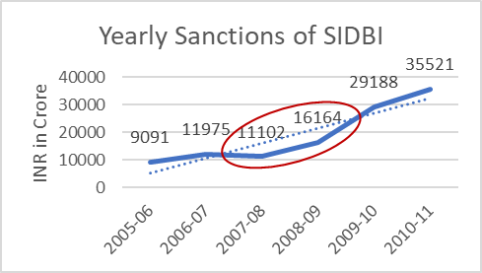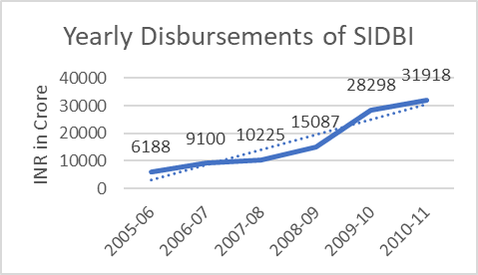

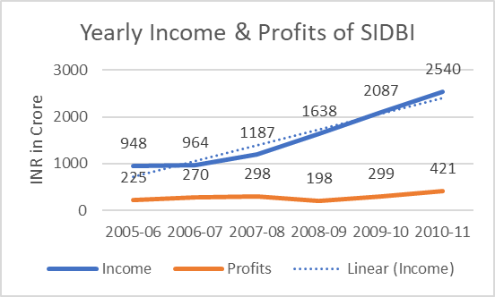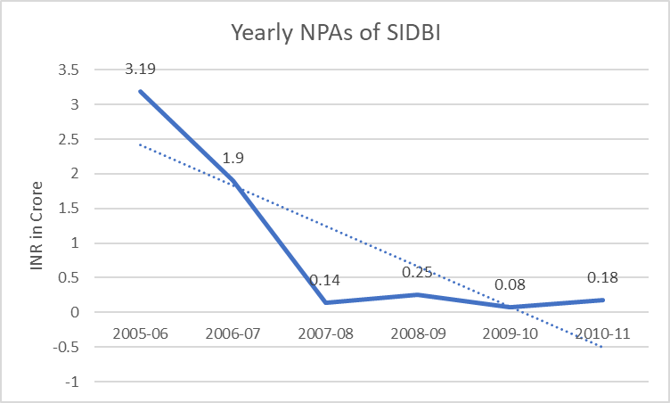

In these times, NPAs too increased for SIDBI compared to the previous financial year by a massive 78.57%. It was majorly because of the uncertainty in the MSME sector caused by the worldwide recession.

A sizeable portion of exposure of SIDBI is through refinancing to State Finance corporations (SFCs). The poor financial health of SFCs during these times had a spillover effect on the financial health of SIDBI as well. Therefore, the risk weight regarding SIDBI’s exposure to SFCs had been raised from 100% to 125%. SIDBI was also instructed not to sanction refinance to SFCs that continued to show negative net worth. These measures were taken to strengthen the regulatory focus of SIDBI over the SFCs.

To enhance the credit delivery to the employment-intensive small and micro enterprises (SMEs), a refinance of INR 7000 Crore was provided to SIDBI on December 6, 2008 by Reserve bank of India.

# Response to COVID - 19

SIDBI has made a special provision in its flagship scheme, Make in India Soft Loan Fund for Micro Small and Medium Enterprises (SMILE). Under this provision, it offers medium and long-dated loans under attractive rates to SIDBI’s existing and new customers. Alongside, to tackle a pandemic caused by COVID - 19, SIDBI has launched many schemes to support the MSME sector.

1. SAFE

**SIDBI Assistance to Facilitate Emergency response against coronavirus**

It allows MSMEs to avail loans upto ₹50 Lacs to manage their operations and create environments for them to control the pandemic. The procured loan can be used to engage in all sorts of value chain activities, starting from raw materials procurement to creating distribution channels for supply and logistics. This scheme focusses on *financing all existing MSMEs* of India who are manufacturing any products or providing any services directly related to fighting the Corona Virus. The USPs of SAFE are:

1. Collateral free loans with approval under 48 hours
2. No processing and prepayment cost
3. Allowance to avail upto 100% financing for capital expenditure
4. SIDBI bears the cost of credit guarantee cover

All formats of MSMEs are eligible for availing SAFE with their criteria set as:

* New New to Bank Customer: must have cash profits for at least 2 years in financial statements and should not have an account registered under the categories of SMA 1/2
* Existing Bank Customer: must have cash profits in the last audited balance sheet and should not have an account registered under the categories of SMA 1/2

The interest rate of the loan has been set to 5% p.a. which reduces on repayment of each loan installment. SIDBI has defined the term loan upto 5 years, including a moratorium with working capital term loan (WCTL) set to 18 months, including moratorium, where promoters’ contribution of 25% is converted into cash collateral. The scheme’s withdrawals are only processed to those registrants who apply for it before December 31, 2020.

1. SAFE +

**SAFE Plus**

It is an extension of SAFE wherein the loan is disbursed to cover upto 100% of the working capital requirement. The loan amount extends upto Rs. 100 Lacs with 5% p.a. MSMEs require orders from any nominated Government body to avail loan under this scheme. The installments are repayable over 4-month cycle based on the execution schedule of Government orders. Rest all aspects are the same as that of SAFE.

1. TWARIT

**Timely Working capital Assistance to Revitalize Industries in terms of coronavirus**

It is a window under Emergency Credit Line Guarantee Schemes (ECLGS) which provides needed relief to MSMEs whose operations are impacted by COVID -19. Startups which have these characteristics can avail TWARIT:

1. Must have GST registration
2. Only applicable to existing borrowers of SIDBI with:
   * combined outstanding credit facilities up to INR 25 crores as on February 29, 2020
   * annual turnover of up to INR 100 crores for FY 2019-20
   * not been classified as SMA 2 or NPA by any of the MLIs as of February 29, 2020

USPs of TWARIT are:

* No processing and prepayment schemes
* No promoter contribution required
* No Guarantee Fee for credit facilities from the borrower; the Trustee Company (NCGTC) shall provide 100% Guarantee coverage on the outstanding amount

Quantum of assistance is defined 20% of total outstanding loans with SIDBI upto INR 25 crore as of February 29, 2020, with cap exposure of INR 5 crore or as modified by the Government of India. Uniform interest rate is 8.25% p.a. with an annual reset. Tenure of the loan is 4 years - moratorium of 1 year + repayment of principal in 3 years. The scheme’s validity has been set upto October 31, 2020. An opt-out option is provided to the eligible borrowers to enable them to choose whether to opt-out of the TWARIT.

1. CSAS

**COVID-19 Startup Assistance Scheme**

The main aim of CSAS is to provide interim support to *startups whose cash flow and liquidity have been adversely impacted by the COVID-19 pandemic*. As SIDBI only specializes in equity and fund infusion, this scheme has been started because of the unprecedented situation and the consequential cash crunch faced by many startups. The startups which qualify the following criteria are eligible:

1. Must be registered under Government and should have raised funding from atleast one Alternate Investment Fund (AIF) by SEBI
2. Positive unit economics & positive net worth
3. Incorporated for less than *10 years*
4. Promoter/ Founder should have invested their capital in the business
5. Employee base of *50+ employees*
6. Minimum turnover between *INR 10 crore* to *INR 60 crore*
7. Should not have any of these conditions
   * Working capital facilities with any bank
   * Written off by AIFs
   * Financial stress besides that imposed by COVID-19

Under CSAS, these eligible partners can avail of a loan of upto INR 2 crore. CSAS also provides insurance coverage of upto INR 10 Lacs to each employee of the availing startup. Its premium cost is split as follows 50% SIDBI, 25% Investor Fund, 25% Startup.

The interest rate for loans procured under this scheme has been set to 10.5% p.a., reducing balance. The loan has to be repaid within a maximum of 24 installments. The tenure of the loan is 36 months, including a maximum moratorium period of 12 months.

1. SLSM

**Scheme for special Liquidity Support to MSMEs**

SIDBI has created 3 divisions inside SLSM

1. **Scheme for special Liquidity Support to MSMEs through NBFCs & MFIs**

It provides resources to NBFCs by way of term loans to ensure operational continuity and promote onward lending to the MSME sector. Features of SLSM are:

* Loan shall be repaid in bullet installment after 90 days from date of drawl
* Processing fee - 0.10% of sanctioned amount subject to a maximum of 5 lakh along with applicable GST

Criteria for NBFCs to avail SLSM are:

1. Registered with RBI as Investment and Credit Company (ICC)
2. In business for 3 years
3. Capital Adequacy ratio to be above RBI requirements, at all times in the past 24 months
4. Minimum Net Owned Funds of INR 20 Crore and Minimum Asset Size of INR 50 Crore

B) **Special refinance scheme for MSME to provide Liquidity Support**

It is directed towards Scheduled Commercial Banks (public, private, Small Finance Banks (SFBs)). Criteria for Banks (SFBs):

* In operation for a period of 3 years
* Earned profit in atleast 2 out of last 3 years
* Networth > INR 200 crores (INR 100 crores)
* Capital to risk-weighted assets > 9% (15%)
* Non-performing assets < 10% (7%)

# 4. Associations and Non-financial Interventions

For creating maximum value and making the economic environment for MSMEs for conducive for growth, SIDBI has created various ecosystems. These subsidiaries are laid out in such a way to propagate and fulfill all kinds of needs of the MSMEs at every growth stage. They have been chalked out by partnering with state and international bodies, with a focus to accelerate growth, create value, and generate maximum financial, social, and environmental benefits to all stakeholders involved.

1. India SME Asset Reconstruction Company (ISARC) – Created in association with leading Public Sector banks (Punjab National Bank, Bank of Baroda, Union Bank, Punjab, and Sind Bank, Indian Bank, LIC, Bank of Maharashtra, Canara Bank, UCO Bank, APSFC, APITCO, Rajasthan Financial Corporation, Kerala Financial Corporation) as India’s 1st asset reconstruction company. Its main objective to acquire NPAs from MSMEs and restructure potentially viable units and liquidate unviable units to maximize asset productivity.
2. SIDBI Venture Capital Limited (SVCL) – Investment management firm wholly owned by SIDBI to engage in startup ecosystem. It manages 7 funds with a total corpus of INR 1,754 crore. Portfolio includes BillDesk, Manthan AI systems, Mosambee, etc.
3. Receivables Exchange of India Limited (RXIL) – Online platform for financing receivables of MSMEs. Incepted as a joint venture of SIDBI and SEBI to manage India’s 1st Trade Receivables Discounting System (TReDS).
4. Credit Guarantee Fund Trusts for MSEs (CGTMSE) - Facilitates credit guarantee support to collateral-free/ 3rd-party guarantee-free loans to MSEs with high credit risk. Approved INR 31 lakh of guarantees covering loans amounting to INR 1.53 lakh crore, thereby creating employment of 1 crore.
5. Micro Units Development & Refinance Agency (MUDRA) - Supports Banks, Micro-finance Institutions (MFIs), NBFCs, and other lending institutions through refinance assistance for onward lending to micro/ small business entities engaged in manufacturing, trading, service sector activities, activities allied to agriculture.
6. India SME Technology Services Limited (ISTSL) – Set up by SIDBI in collaboration with Indian Bank, Oriental Bank of Commerce, Indian Overseas Bank, and State Bank of India. Offered technology advisory and consultancy services to MSMEs and provided a platform to tap opportunities at the domestic and global levels to acquire modern technologies.
7. Acuité Ratings & Research (ACUITE) – Credit rating agency set up by SIDBI, Dun & Bradstreet Information Services, ICICI, SBI, Bank of India, Oriental Bank of Commerce, Union Bank, Indian Bank, PNB, Standard Chartered. Completed more than 7000 credit ratings. It also has a special department called SMERA dedicated to rating SMEs.

Other than these ecosystems, SIDBI has taken lot of measures for non-financial interventions in MSME sector.

1. CriSidEx – India's 1st sentiment index for MSMEs jointly developed by CRISIL & SIDBI. It judges the business sentiment of MSMEs on a scale of 0 (extremely negative) to 200 (extremely positive) based on an index based on a diffusion index of 8 parameters. Its reading also flags potential headwinds and changes in production cycles and thus help improve market efficiencies.
2. MSME Pulse – Developed by SIDBI and TransUnion CIBIL. It generates a quarterly report on MSME credit activity for closely tracking and monitoring the MSME segment in the country. The report is based on a study done on over 5 million active MSMEs who have access to formal credit, with live credit facilities in the Indian banking system.
3. Udyami Mitra – SIDBI has partnered with CSCeGS (a special purpose vehicle set up by the Ministry of Electronics and MeitY) to establish Udyami Portal to the unserved and the underserved MSMEs.

____________________________________________________________________________________________ End of Report. © Academic License v3.0